1. Which industries saw the most growth?

The data indicates that the Consumer Products & Services and IT Services industries experienced the most significant growth, with percentages over 250,000%. These industries likely benefited from increased consumer demand and technological advancements, respectively.

Other high-growth industries include Health, Advertising & Marketing, and Business Products & Services, each demonstrating substantial growth. This suggests a robust expansion across a diverse set of sectors, reflecting broader economic trends and possibly the impact of innovation, market demand, and investment in these areas.

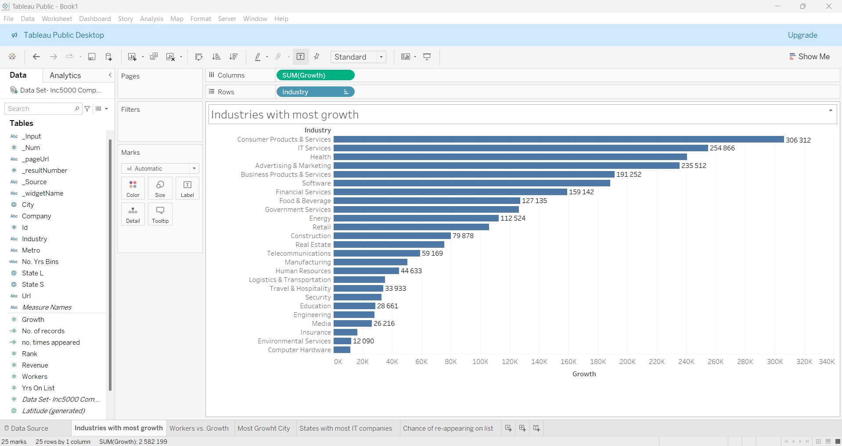

1. Do companies that have been on this list longer have a higher chance of appearing again in this list?

The provided data from the 2014 Inc. 5000 dataset shows the distribution of companies based on the number of years they have appeared on the list:

1 Year: 37.36% (1,868 records)

3 Years: 34.76% (1,738 records)

5 Years: 16.32% (816 records)

Over 5 Years: 11.56% (578 records)

This distribution indicates that as the number of years on the list increases, the percentage of companies in each category decreases. This might initially suggest that fewer companies remain on the list over time.

However, to conclusively determine if companies with longer tenures on the list have a higher chance of reappearing in future lists, further analysis is needed. Specifically, we would require:

Historical data showing the same companies' reappearance rates over subsequent years.

An analysis of the survival rates of companies on the list over a span of multiple years.

In summary, while the current data shows a decreasing trend in the percentage of companies with longer tenures on the list, it does not provide sufficient information to definitively conclude that longer-listed companies have a higher probability of future appearances. More comprehensive longitudinal data is necessary for a conclusive analysis.

1. Does the number of workers in the company affect the growth of the company?

The correlation between the number of employees and the growth of a company is not always indicative of success. As evidenced by the data in the screenshots provided, it is clear that having a large workforce does not necessarily equate to significant growth. In fact, there are companies with a relatively small number of employees that are experiencing substantial growth. This suggests that factors other than employee count, such as innovation, market strategy, and operational efficiency, are critical drivers of company expansion. It underscores the idea that a lean, well-organized, and highly skilled team can outperform larger organizations in terms of growth.

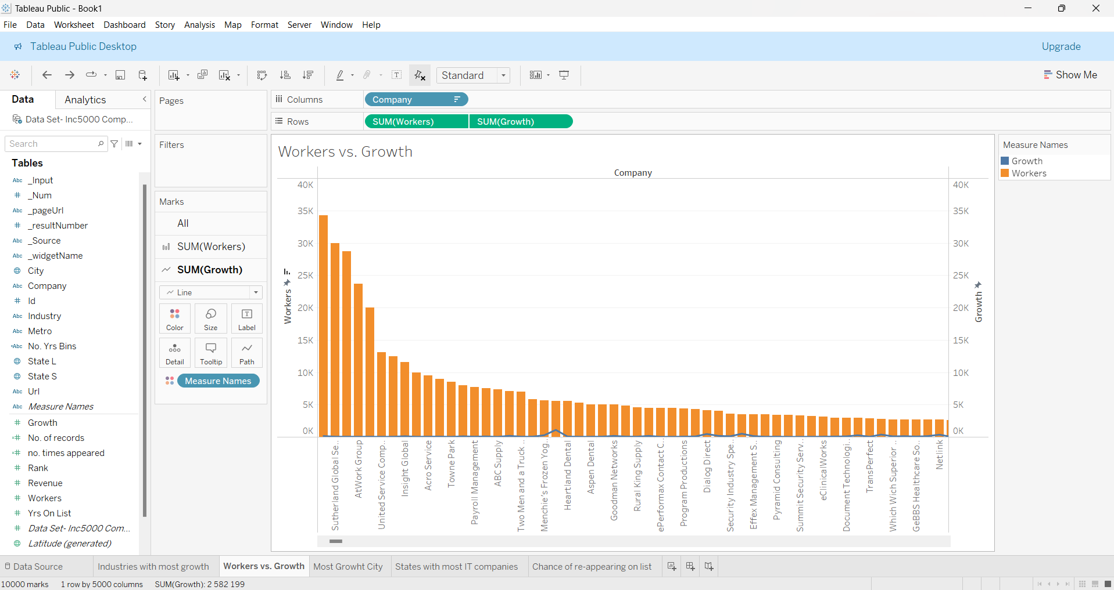

1. Which state can you find most of the IT companies in?

The data clearly shows that California is the state with the highest number of IT companies, followed by Texas and New York. This distribution indicates a significant concentration of IT companies in these states, which are likely hubs for technology and innovation.

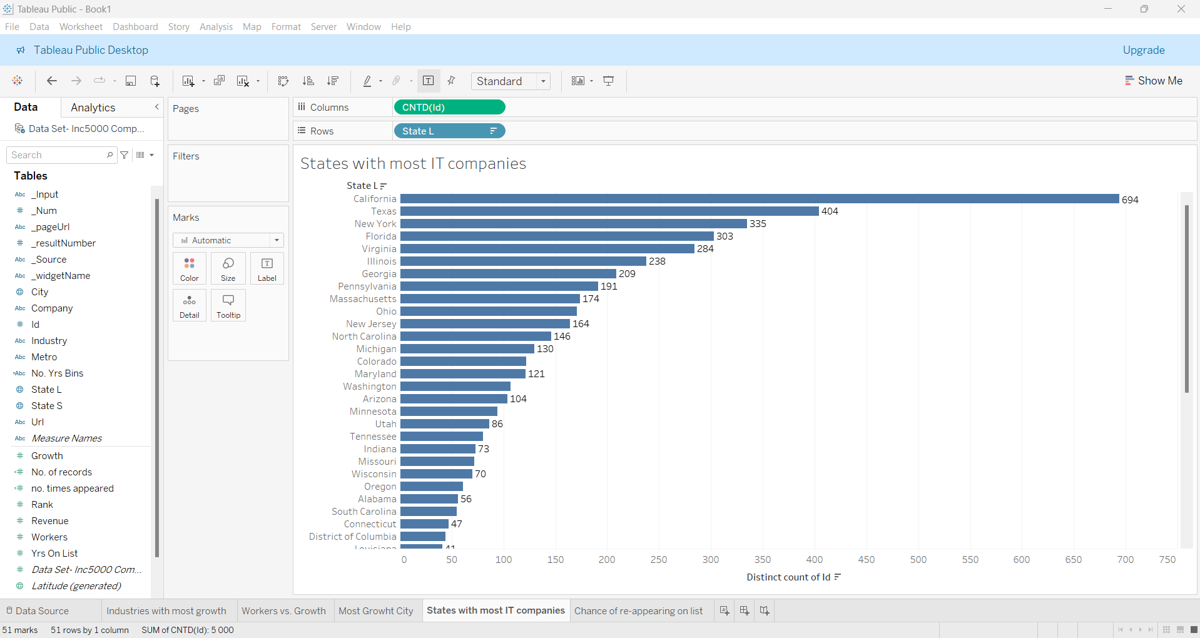

1. Which cities have seen the most growth?

The cities listed have seen substantial growth, with El Segundo and New York leading the list by a significant margin. These growth figures likely reflect various factors such as economic development, population increase, and business expansions in these areas.